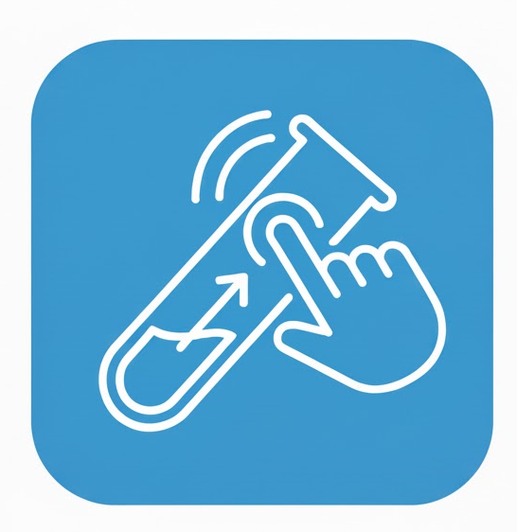
SwipeLab – Software Requirements Specification (SRS)

1. Introduction
SwipeLab is a mobile application designed to assist researchers in collecting and classifying visual data through crowd participation. Users receive a series of reference images and classify them by swiping – similar to a Tinder-like interface (Yes / No / Maybe). The labeled data is used to train and improve research models, providing an engaging, user-friendly experience for contributors.

1.1 Purpose
The purpose of this document is to specify the functional and non-functional requirements of the SwipeLab application. It provides a detailed description of the system’s capabilities, user interactions, and constraints, ensuring clarity among developers, stakeholders, and researchers.

1.2 Scope
SwipeLab aims to simplify the process of collecting labeled image data for research purposes. Researchers provide an API to retrieve image datasets, and users classify these images intuitively. The system also features user engagement mechanisms such as points, rankings, and badges to promote continuous participation.

2. Overall Description

2.1 Product Perspective
SwipeLab operates as a standalone mobile application that interacts with a remote research dataset API. It includes user authentication via Google, data fetching, image classification functionality, and data submission to the backend server for aggregation and analysis.

2.2 Product Functions
• Retrieve dataset images securely from the research API
• Present images for classification (Yes / No / Maybe swipe interface)
• Store and submit user responses
• Display user statistics and leaderboard
• Manage authentication using Google Sign-In
• Track progress and engagement via points, levels, and badges

2.3 User Characteristics
Primary users are individuals participating in research projects by classifying visual data. They may have minimal technical background; therefore, the interface must be simple and intuitive. Researchers act as system administrators responsible for managing datasets and reviewing aggregated classifications.

3. System Features
1. User Authentication
- Secure login using Google authentication
2. Image Classification
- Swipe left/right/up for Yes/No/Maybe decisions
3. User Scoring System
- Assign points and levels based on activity and accuracy
4. Leaderboards and Badges
- Display top contributors and reward consistent users
5. Data Synchronization
- Store results locally and sync with backend when online
6. Research API Integration
- Communicate securely with the customer’s dataset API

4. External Interface Requirements
• Mobile Interface: Built using React Native with Expo for Android/iOS compatibility.
• Backend Server: Developed with Java Spring Boot to handle authentication, data storage, and API communication.
• Database: PostgreSQL for structured data management.
• API: Secure RESTful integration with the research dataset provider.

5. Non-Functional Requirements
• Usability: Interface must be simple, responsive, and suitable for casual use.
• Security: Data and authentication must be protected via HTTPS and OAuth.
• Performance: Must support concurrent users with minimal delay when fetching images.
• Reliability: Ensure consistent uptime and error handling for network interruptions.
• Scalability: Support future expansion to larger datasets and more users.

6. Assumptions and Dependencies
• The research dataset API will be accessible and maintained by the customer.
• Users will have stable internet connections for data synchronization.
• The project team will collaborate with the API provider to adapt and integrate endpoints.
• Google authentication services will remain available and operational.

7. Future Enhancements
• Add support for multiple datasets and research projects.
• Enable offline mode for temporary data storage.
• Expand the gamification system with seasonal challenges.

Detailed System Requirements

1. Functional Requirements

1.1 User Management
- FR-1.1.1: The system shall allow users to sign in using Google authentication.
- FR-1.1.2: The system shall create and maintain a user profile with name, email, and cumulative score.
- FR-1.1.3: The system shall display a profile dashboard showing user level, tier, and progress.
- FR-1.1.4: The system shall allow users to log out securely.

1.2 Dataset Retrieval and API Integration
- FR-1.2.1: The system shall connect to the researcher’s dataset API using a secure REST protocol (HTTPS).
- FR-1.2.2: The system shall fetch batches of images for classification from the API.
- FR-1.2.3: The system shall handle API response errors gracefully (e.g., timeout, invalid token).
- FR-1.2.4: The system shall cache images locally for performance and offline resilience.
- FR-1.2.5: The system shall support dynamic dataset updates without requiring app redeployment.

1.3 Image Classification Module
- FR-1.3.1: The app shall display one image at a time for user classification.
- FR-1.3.2: The user shall classify each image using a swipe gesture:
  - Swipe right → “Relevant / Yes”
  - Swipe left → “Not Relevant / No”
  - Swipe up → “Unsure / Maybe”
- FR-1.3.3: The app shall store the user’s decision locally and send it to the backend asynchronously.
- FR-1.3.4: The app shall provide visual feedback (animation or highlight) after each swipe.
- FR-1.3.5: The app shall prevent duplicate classification of the same image by the same user.

1.4 Scoring and Gamification System
- FR-1.4.1: The system shall assign points for each classification made.
- FR-1.4.2: The system shall compare user decisions to expert labels (when available) and adjust credibility score.
- FR-1.4.3: The system shall maintain levels and tiers based on user activity and accuracy.
- FR-1.4.4: The system shall show leaderboards for “LabSwiper of the Week” and “LabSwiper of the Month.”
- FR-1.4.5: The system shall award badges or titles for milestones (e.g., 500 swipes, 95% accuracy).

1.5 User Statistics and Feedback
- FR-1.5.1: The app shall display personal statistics:
  - Total classifications
  - Accuracy vs. expert labels
  - Points and level
  - Weekly and monthly performance
- FR-1.5.2: The app shall provide visual progress indicators (graphs, bars, streaks).
- FR-1.5.3: The app shall compare the user’s performance with the average researcher accuracy.
- FR-1.5.4: The app shall allow users to view their rank among all contributors.

1.6 Researcher / Admin Features
- FR-1.6.1: Researchers shall be able to configure which dataset is currently active for labeling.
- FR-1.6.2: Researchers shall be able to define labeling categories and swipe meanings.
- FR-1.6.3: Researchers shall have access to a dashboard summarizing user activity and dataset progress.
- FR-1.6.4: The system shall allow exporting aggregated classification results in CSV/JSON format.
- FR-1.6.5: The researcher dashboard shall show accuracy trends and participation metrics.

2. Non-Functional Requirements

2.1 Performance
- NFR-2.1.1: Image loading time shall not exceed 1.5 seconds on average.
- NFR-2.1.2: The app shall support at least 100 concurrent users without degradation.
- NFR-2.1.3: The system shall synchronize cached results within 30 seconds of regaining connectivity.

2.2 Security
- NFR-2.2.1: All communications between app, backend, and API shall use HTTPS encryption.
- NFR-2.2.2: Authentication shall use OAuth 2.0 tokens.
- NFR-2.2.3: User data shall be stored with hashed identifiers to protect privacy.
- NFR-2.2.4: The backend shall validate every API request to ensure proper authorization.

2.3 Usability
- NFR-2.3.1: The interface shall be intuitive and swipe-based, usable without instructions.
- NFR-2.3.2: The app shall follow mobile accessibility standards, including contrast and font size.
- NFR-2.3.3: The app shall support dark and light themes.
- NFR-2.3.4: All feedback and animations shall be under 500ms to feel responsive.

2.4 Reliability and Availability
- NFR-2.4.1: The system shall maintain 99% uptime for backend services.
- NFR-2.4.2: The app shall queue classifications offline and sync automatically once online.
- NFR-2.4.3: System logs shall record all API interactions for debugging.

2.5 Scalability and Maintainability
- NFR-2.5.1: The system architecture shall allow adding new datasets and categories with minimal code changes.
- NFR-2.5.2: The backend shall support horizontal scaling (multiple instances).
- NFR-2.5.3: The codebase shall follow modular design principles to support maintenance.

2.6 Portability
- NFR-2.6.1: The application shall run on both Android and iOS devices.
- NFR-2.6.2: The backend shall be deployable on cloud or local server environments.

2.7 Legal and Ethical
- NFR-2.7.1: The app shall not collect personal data beyond what’s necessary for authentication.
- NFR-2.7.2: Users shall consent to data collection and agree to a privacy policy.
- NFR-2.7.3: The app shall comply with GDPR and local data protection regulations.

